# CS7GV6 Computer Graphics Assignment 1

## Van Allen Bruns Jr - 19329560

# Compulsory Elements

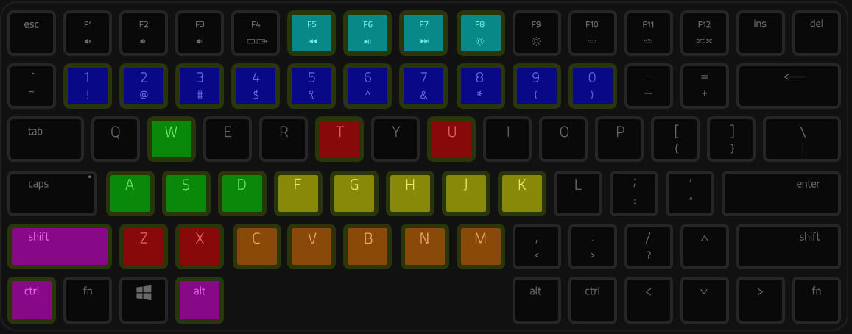All compulsory elements were implemented in labs prior to this assignment except for lighting and shading, so the focus of this report is covering lighting and shading. Before we begin, here’s an outline of the keyboard controls for this assignment:

|  |  |  |
| --- | --- | --- |
| **Viewport Toggle**  F5: Top Left  F6: Top Right  F7: Bottom Left  F8: Bottom Right | **Object Selection**  0-9: Individual selection  Ctrl-a: select all | **Transformation**  Ctrl-xyz: Light move toggle  Shift-xyz: Translate  xyz: Rotate  u: Scale  +alt: Reverse (except light) |
| **Movement**  w: Forward (based on eye)  a: Left  s: Backward (based on eye)  d: Right | **Left Arm Rotate (+alt)**  f: Forward shoulder  g: Side shoulder  h: Upper arm  j: Elbow  k: Forearm | **Right Arm Rotate (+alt)**  c: Forward shoulder  v: Side shoulder  b: Upper arm  n: Elbow  m: Forearm |

# A close up of an animal Description automatically generatedLighting and Shading

Initially, I had trouble with the slides, so I consulted (DISQUS, 2019). Then, I turned to (John Kessenich, 2017) for inspiration. The result looked great, but reflection didn’t follow the eye of the viewer. Finally, I combined all of them together to create a highly-customizable shading scheme.

You can see here the ambient, diffuse, specular, and combined results. For the shaders, notice all the uniform variables, meaning we can tweak the light source and object material properties until we get exactly what we want!

|  |  |
| --- | --- |
|  |  |

# References

DISQUS. (2019, October 25). *Basic Lighting*. Retrieved from Learn OpenGL: https://learnopengl.com/Lighting/Basic-Lighting

John Kessenich, G. S. (2017). *OpenGL Programming Guide Ninth Edition.* Crawfordsville, Indiana: Pearson Education, Inc.